Corporate Profile

Of
Obutrans Services Limited

About Obutrans
Obutrans is a wholly Nigerian-owned proprietary maritime logistic and ancillary services firm incorporated under the laws of the Federal Republic of Nigeria as a limited liability company with the Corporate Affairs Commission to carry on the business of Haulage, Maritime logistics, Freight Forwarding and Clearing, Risk Management and Insurance Advisory services for key sectors of the Nigerian economy
We combine competent, experienced and certified professionals in the maritime, risk management, quality assurance, construction engineering and other service industry with various backgrounds.

We are a multi-disciplinary practice, with a team which has varied experience in a wide range of projects which include bonded terminal operations, maritime transport logistics – fully loaded containerized cargo and empty transfer, general building construction and design, civil engineering works and design, landscape design, industrial design and construction, institutional design, planning and design of commercial and educational facilities and residential design

Obutrans specializes in various forms of transport & logistic services. We provide movement of cargos & empty containers within Lagos and anywhere in Nigeria. We also render car hire as well as fleet management services to individuals and corporates. Our vision is to be a top-notch transport provider to Shipping Companies, Exporters & Importers in a way and manner that ensures effective and efficient cost management for our clients.

Our Vision
To become the preferred provider of innovative logistic and risk management solutions for wide range of clients.

Our Mission
To revolutionalise the practice of marine logistics and insurance advisory through innovation, technology & our people there by becoming the preferred provider of choice.

Our Core Values
In view of the competitive nature of the market, we will ensure professionalism, excellent services, innovation, integrity and customer satisfaction by applying the rules of knowing our clients, speedy response to their requests and total commitment to best practices.
Integrity

Professionalism

Service Excellence and speed
Safety
Technology Driven

Our Team

Engr. David Ogbe - Chairman
Engr Ogbe oversees our building and construction services. He has over three decades professional experience in Building Construction, Civil Engineering, Facility and Procurement Management having served in different capacity while working with leading organization, particularly as Manager, General Services at AfricaRe

He is a Fellow of Nigerian Institute of Building Construction ( NIOB ), Member of Council of Registered Builders of Nigeria ( COBON ) F .136 and a member of International facility management. Holds Master Degree in Constructions Technology from McGill University, Montreal Canada (1991) & MBA with specialization in Construction & Real Estate Accounting. He has his first degree (B.Sc.) & M.Sc. in (Building & Construction Technology) both from Ahmadu Bello University Zaria, Nigeria with a Post Graduate course in Reinforced concrete

Professional Work Experience Position Year
African Reinsurance Corporation ( Lagos Nigeria ) Manager 2003 -2021
African Petroleum Plc , 54/56 Broad Street Lagos Assistant Mgr. 1992 -2003
Ahmadu Bello University, Zaria ( Blding Dpt) Lecturer 1986 - 1992
Nigerian Ports Authority , Port Harcourt Civil Engineer 1984 - 1986

Mr. Sunday Ojile - Director/COO
Mr. Ojile is a Director in charge of sales and business development across the group business with knack and deep knowledge of the Nigerian Maritime Logistic space.

He is a member of the Nigerian Institute of Management with over 10 years hands-on experience in bonded terminal and holding bay operations, clearing and forwarding and critical regulatory licensing procedures while working with EMOG bonded Terminal, COSCO Shipping and a number of Leading Shipping Lines in Nigeria.

He is currently undergoing a post graduate diploma PGD program in Transport at the University of Lagos and holds HND in Marketing from Yaba College of Technology

He has attended various trainings ranging from Strategic Logistic and Fleet Management to Fleet Preventive Maintenance Course among others.

Mrs. Elizabeth Adikwu – Director (Resources)

Elizabeth is an acknowledged Administrator and a trained developmental communication expert. An Entrepreneur per excellence with over 5 years’ experience in administration practical experience in fleet management. She is a theatre practitioner and a development communicator, a twin discipline, which she obtained differently in her first and 2nd degree from the famous Ahmadu Bello University.
These Disciplines in the humanities have greatly enabled her to gain grounds in various levels of humanitarian activities, where she featured as a partner, collaborator, volunteer, peer educator, monitoring/evaluation as well as community development communicator cum facilitator. In her few years of practice, she had been a resource person and a volunteer with USAID, WHO and few other vocational training centres. Chiefly, she has been a part of the field and community-based development and intervention activities of the Dept of theatre arts, ABU, Zaria while in the classroom and outside the classroom. These fieldworks are geared at reaching out to different categories of target audience. Basically carried out to curb some societal malaise and health related challenges such as polio, HIV/AIDS, cholera, sociocultural issues such as early marriages, girl-child education etc.
She is currently the Team Lead, Resources.

Mr. Williams- Director/CEO, Insurance Advisory
Williams is a highly driven business development professional with over 15 years’ experience in Insurance, Training and Development. Skilled in converting opportunities and closing mega deals. A goal getter & astute business leader with unusual ability at leading teams to achieve targets at least cost, through strategic planning, innovation, and determined execution.

He started his insurance as a marketing executive with African Alliance Insurance before moving to SCIB Nigeria and Company as a Business Development Associate driving big ticket insurance transactions in the Oil and Gas, Telecoms and Hospitality Sectors. He was involved in bidding and tendering for most public and multinational Insurance accounts while at SCIB. A director at Marvin Williams Services

Williams is an associate member of the Chartered Insurance Institute of Nigeria (ACIIN), Nigerian Institute of Training & Development and an ISO 9001:2015 Lead Auditor QMS Certification (HKV) UK.

He Joined Obutrans Insurance Brokers from Megatech Insurance where he led the strategy and technical

Academic Background
He has his first degree in Sociology (2001) from the Benue State University and also holds Professional Diploma in Marketing FROM(CIM UK) as well as MBA degree from the University of Ibadan.
He holds Masters in Business Administration (2021) from University of Ibadan
Associate Accounting Technician (ICAN) - 1998
Associate (Nigerian Institute of Training & Development) - 2016

Mr. Sadiq Akinselu Fasipe Chief Operating Officer
Fasipe, Sadiq Akinseku, A Post-graduate Diploma Holder in transport management from Olabisi Onabanjo University has considerable theoretical and practical experience in Logistics and supply chain management and brings on board of Obutrans Services Team a commendable value add-on. He currently Hold a certificate in store management, fleet management and transport logistics and also hold an international certificate in logistics and supply chain management from INTERNATIONAL SCHOOL OF MANAGEMENT.

He worked with Aquila Leasing Limited as fleet Management Officer before joining Obutrans Team. Before then, he was a Fleet Supervisor (Dispatch) at Multimoder Transport Limited.

Sadiq also holds a National Diploma in Accountancy from Osun State Polytechnic Iree Osun state

OUR SERVICES

Cargo & Empty Container Delivery
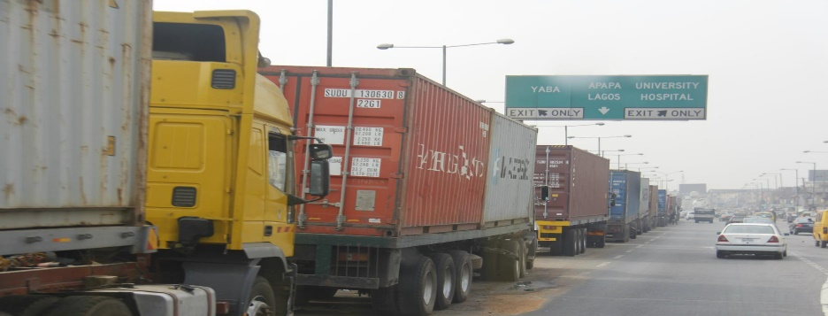 | 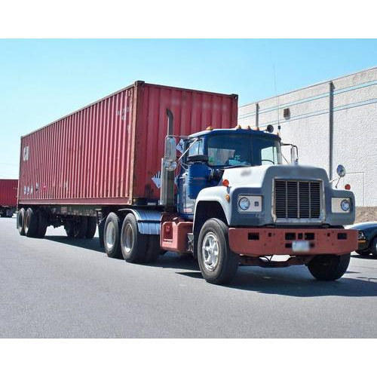
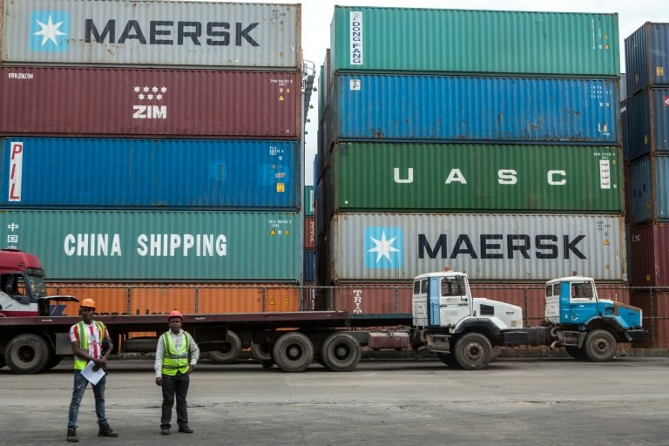 | 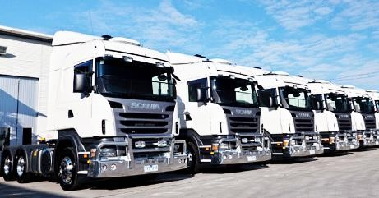
Our delivery Services save you the troubles and challenges associated with managing delay in container movement and cargo delivery. All ownership risks are borne by our company. Our clients only pay rental fees pre agreed from time to time

Obutrans Customs Clearing Agency/Air Cargo shipping

Leveraging a designed-build-operate solution for Maritime industry, this business unit provides knowledgeable personnel who laisse with the government agencies and facilitates duty payment for all import goods as well as export Customs documents and Clearing to ease the clearing processes, shipping of any goods from Nigeria to any part of the world by air takes about 3-5 working days with other benefits like the door delivery, cheap and affordable rates. This team also provides government customers with ship management and other Maritime related services; supply chain and freight transportation management services.

Supply Chain Solutions and Consulting:
Our supply chain solutions consulting team can help you increase revenue, reduce cost, improve service levels and efficiency and reduce your exposure to business risk. Among other value add services, the team can evaluate your sourcing and transportation options to determine if natural resource or other government laws is a viable option for your business to expand its borders.
This evaluation explores a range of potential advantages including fewer cultural, linguistic; more involvement in day-to-day decision making; reduced travel expenses; greater regulatory alignment; and less risk to intellectual property.
We will evaluate your current material and information flows and design future state options to meet your supply chain needs. This results in a higher return on investment while freeing your internal resources, allowing you to focus on improving your core competencies.
Air freight:
When land or sea alone don’t meet your cargo movement needs, Obutrans supply chain specialists offer effective and efficient air freight cargo routing across the sky with affordable cost, fast/quick delivery and at ease.
This allows us to close the loop on your supply chain by carefully planning your cargo route using our network of carriers who provide direct, all-cargo flights within Nigeria and from Nigeria to the world at large.

Insurance Advisory

Our Insurance Brokerage advisory services division – Obutrans Insurance Brokers (OIB) is fully equipped and licenced by the National Insurance Commission (NAICOM) to transact in Life and General insurance. OIB aspires to be the preferred insurance broker of choice in the Nigerian Insurance market

IB has a dynamic team of qualified and experienced professionals that manage and direct the affairs of the firm.

Logistics Support Services
We recruit and manage drivers, operators and other support staff for big corporates. Under our Logistics Support Services, we provide protocol services at the various Nigerian Airports. The protocol services include but not limited to meet & greet, immigration and customs clearance and escort services from Airports to town and within the town as long as the visitor needs the security.

Our Target Market
- Shipping Companies
- Importers & Exporters
- Corporates seeking delivery of their goods

OUR PARTNERS
In order to meet the diverse needs of our clients, our company established and maintains good relationship with some financier services firm banks in Nigeria. We currently have banking relationship with Guaranty Trust Bank & United Bank for Africa (UBA) Plc and Zenith Bank Plc

OUR TECHNICAL PARTNER
Obutrans partners and engages the services of leading insurance companies to manage our risk exposure, qualified vendors, transporters and Government agencies for all our assets acquisition, repairs, rescue and recovery, training and retraining of our employees in the area of HSE. We constantly relate with the Federal Road Safety Commission, VIO, Fire Service and Environmental Protection agencies.

We have a valid combined all risk insurance policy (Goods in Transit -GIT, Public Liability & Fidelity Guarantee) that provide us cover against the risk of accidental damage, fire or theft involving goods while in transit in our owned vehicle or hired vehicle from other transporters. This guarantee the safety of our clients’ asset in our custody until delivery.

In addition, we engage the services of specialized and approved vehicle vendors for the procurement/supply of vehicles, spare parts, servicing and maintenance of our various brands of vehicles.

In Obutrans Services Limited, we believe so much in professionalism, and by the virtue of this, we maintain fair spread of garages and service workshops in the areas we operate. Currently, we have garages/services workshops across Lagos and selected parts in upcountry.
We engage the services of specialized and approved vehicle vendors for the procurement/supply of vehicles, spare parts, servicing and maintenance of our vehicles
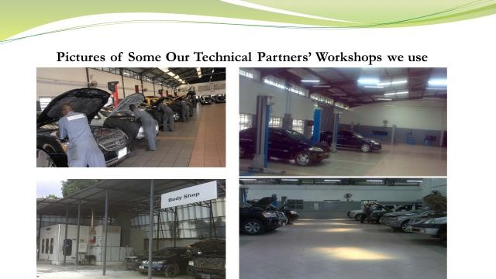
We continually review and expand supplier/vendor base to mitigate against uncertainties or delay in service delivery that may affect the performance of our contracts.

REASONS OUR CUSTOMERS CHOOSE OBUTRANS
Our core values of integrity, professionalism, innovation, team-work, dedication and speed set us wide apart from our competitors. We are focused on developing and maintaining measurable customer satisfaction by delivering world-class service to our clients.
We offer our clients
24/7 support service
Experienced and motivated workforce
Responsive and flexible service options
Wide geographical coverage (our vehicles are currently operating in all the states of Nigeria
Adherence to safe work procedures. We are driven by our Health, Safety and Environment (HSE) policy.
Superior and efficient Technology enables us deliver efficiency speedily. Reports are generated for our clients for management decision making.
Existing technical alliances with authorized vehicle dealers for the maintenance of our vehicles and training of our technical staff.
We offer to provide first class service with unparalleled professionalism to enable your company focus on its core businesses. We have the capacity to efficiently and effectively support your operations. We are tested and trusted.

OUR CONTACT DETAILS

HEAD OFFICE

54, Calcutta Crescent,
Apapa Lagos,
Off Oshodi-Apapa Expressway
Oshodi, Lagos

AGENCY OFFICES
Obutrans Services Limited maintains agency/Liaison offices in Port Harcourt, Abuja & Makurdi. The agency offices are points of contacts for our Regional Supervisors in-charge of the daily operations of our activities in these locations.
Abuja Liaison Office:
Plot 234
Dutse Alhaji
Zone 6
Abuja

Port Harcourt Liaison Office
4 Nwafor Cresent,
Off Jesus Avenue
Umuebule 1 Oyigbo
Port Harcourt

WEBSITE: www.obutrangroup.com
EMAIL: obutransservicesltd@gmail.com, info@obutransgroup.com,
Tel: +234-08033111782, +2347056154611

